
My Five Favorite Foods
Centered
Size = 18
Bold

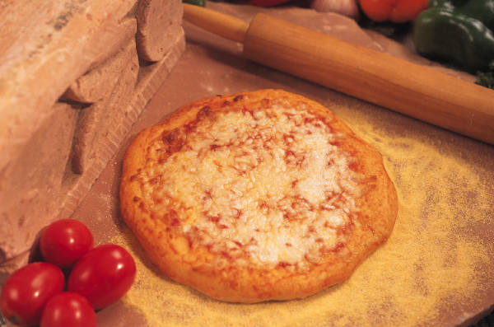Pizza
Type your five favorite foods. Press Enter after each word.

Steak
Click the Insert Tab on the Ribbon.
Click ClipArt.
Type in the food word in the Search for: box.
Insert your picture at the blinking insertion point.
Resize the picture using the handles.
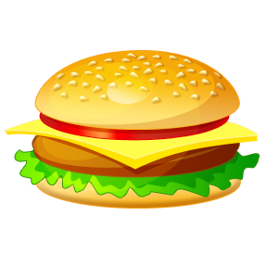Cheeseburger
Enchiladas
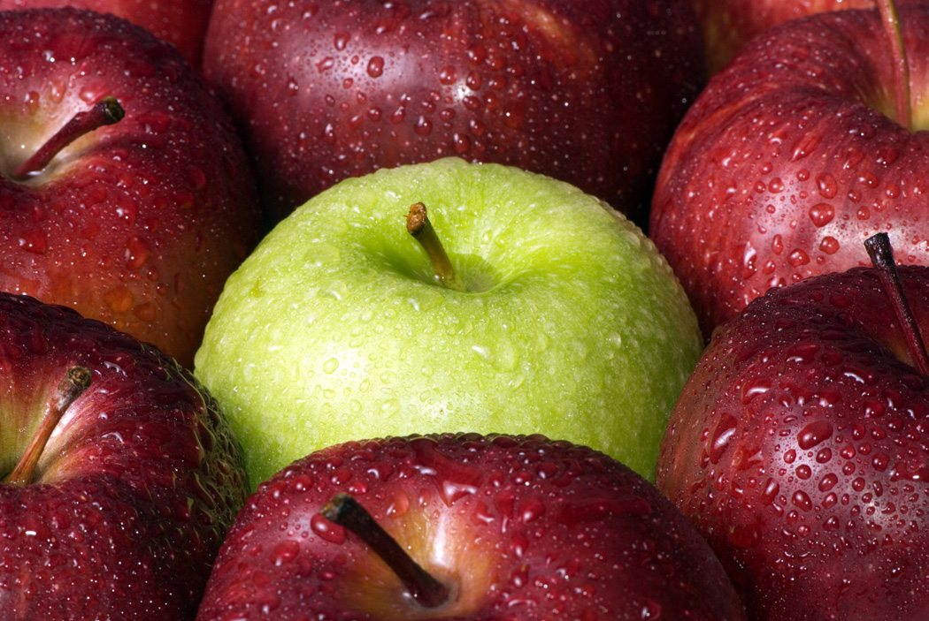Apple
My Five Favorite Foods
Pizza
Steak
Cheeseburger
Enchiladas
Apple

